Digitrax Speakers Specification Sheet

SP282832 Round 32 Ohm Speaker with Wires
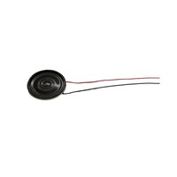

Interface | Wires

Prod Date | 01/29/2012 | Discontinued | Current | Replaced By | Current
MSRP | US$9.00 | Size | 28mm | SKU
Scale | HO | Ohms | 32

Digitrax, Inc. is not responsible for unintentional errors or omissions in this document.

