Digitrax Mobile Decoders Specification Sheet

DHDP Dummy Plugs (5 pack)
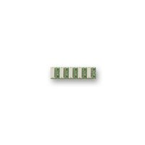

Decoder Interface | DHWH, DHWHP, DHWHPS
Quantity | 5
Compatible With | DC Locomotives
Compatible Lighting | Incandescent Lamps

Prod Date | 12/31/06 | Discontinued | Current | Replaced By | Current
MSRP | US$20.00 |  |  | SKU

Digitrax, Inc. is not responsible for unintentional errors or omissions in this document.

